**Rockabill Film Society, Skerries**

**Spring Season 2019**

### All films start at 8.30 pm in the Skerries Sailing Club. Tickets / membership at the door.

[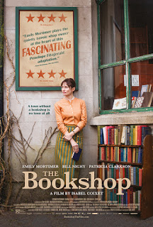](https://4.bp.blogspot.com/-4xOsWRg-8y0/XBqvFcqWp0I/AAAAAAAAEfA/6YSR66GNUYYycPa0ZjRVBSrzLynWrQAAACLcBGAs/s1600/The%2BBookshop%2BPOSTER.jpg)***Wednesday 9 January – The Bookshop***  
Dir: Isabel Coixet, 2017, UK, 113 mins, Cert: PG  
Starring: Emily Mortimer, Bill Nighy, Hunter Tremayne  
Language: English  
Trailer: <https://www.youtube.com/watch?v=c8-4E4XJyKg>  
  
Florence Green, a free-spirited widow, puts grief behind her and risks everything to open up a bookshop -- the first such shop in the sleepy seaside town of Hardborough, England. But this mini social revolution soon brings her fierce enemies: she invites the hostility of the town's less prosperous shopkeepers and also crosses Mrs. Gamart, Harborough's vengeful, embittered alpha female who is a wannabe doyenne of the local arts scene.  
  
 ***Wednesday 23 January – The Guilty***  
*Den skyldige*  
  
Dir: Gustav Möller, 2018, Denmark, 85 mins, Cert: Club  
Starring: Jakob Cedergren, Jessica Dinnage, Johan Olsen  
Language: Danish  
Trailer: <https://www.youtube.com/watch?v=abaoKA6rn5k>

[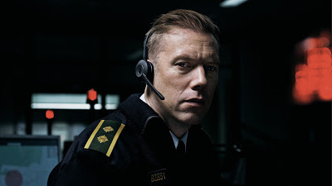](https://3.bp.blogspot.com/-xARW90WZ_ag/XBqw2yyq6II/AAAAAAAAEfM/aoXMIDxpUuY61DBbiaA7dD48Y-88fO0cQCLcBGAs/s1600/The-Guilty_headset-01.jpeg)

Demoted to deskwork and awaiting a disciplinary hearing, Agent Asger is working the night shift in an emergency call room. When he receives a call from a woman who has been abducted his resolve and arrogance are tested as it becomes a race against time to locate her.  Taking place in real time and in a single location nothing is quite as it seems in this claustrophobic thriller.  Using sound as the primary storytelling tool and with a powerful central performance from Jakob Cedergren, The Guilty is a visceral viewing experience.  
  
Awards:  
*Winner* - World Cinema Audience Award, Sundance Film Festival 2018  
*Winner* – Audience Award, International Film Festival Rotterdam 2018  
*Winner* – Youth Jury Award, International Film Festival Rotterdam 2018

***Wednesday 6 February – 1945***  
Dir: Ferenc Török, 2017, Hungary, 91 mins, Cert: Club  
Starring: Péter Rudolf, Bence Tasnádi, Tamás Szabó Kimmel, Dóra Sztarenki  
Language: Hungarian  
Trailer: <https://www.youtube.com/watch?v=HZbhnWBZWy0>

[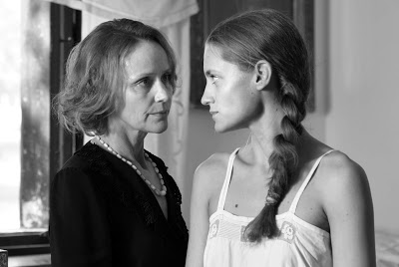](https://4.bp.blogspot.com/-WwE3ehL5MMI/XBqy-ab6crI/AAAAAAAAEfY/okaKBp23ehggBHOgZuwBurJsizYvVLBwgCLcBGAs/s1600/LSD_8638.JPG)When two black clad men arrive at a country railway station, a classic western set up appears to be unfolding. But it’s 1945 in Soviet-occupied Hungary in the immediate aftermath of World War II, and by their appearance the men are Orthodox Jews. As the two men make their way to town and word of their arrival spreads, there’s a growing panic amongst some of the more prominent townsfolk - especially town clerk, István, whose son’s wedding is later that day…  
  
This difficult, transitional time in Hungary is a period rarely dealt with in cinema, and certainly not with as much clarity, economy and nuance as Ferenc Török displays here. A rare subject too, the grave and sobering issue of how the Gentile population of Nazi-occupied countries behaved towards Jewish neighbours, and how they have, or haven’t, variously, come to terms with a life based on guilt and betrayal. With its monochrome splendour and striking soundtrack, morally compromised townspeople and its tick-tock narrative towards an unknown conclusion, we’re reminded of Fred Zinnemann’s taut and masterful *High Noon*.

*“A fresh, intelligent cinematic approach to a difficult topic that takes on a transitional time in Hungarian history with subtlety and nuance.” –*Alissa Simon, Variety

[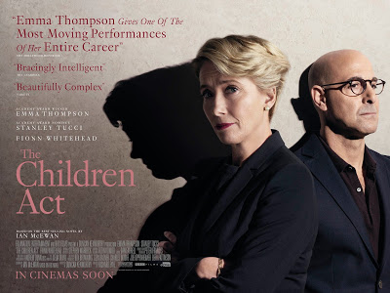](https://3.bp.blogspot.com/-C2rjYifooPY/XBq0a7JWPdI/AAAAAAAAEfk/kbpECLzqfnkEJ61k5S_Rwc4VaMpSF627gCLcBGAs/s1600/the_children_act_quad.jpg)

***Wednesday 20 February – The Children Act***  
Dir: Richard Eyre, 2017, UK/USA, 105 mins, Cert: 12a  
Starring: Emma Thompson, Stanley Tucci, Fionn Whitehead  
Language: English  
Trailer: <https://www.youtube.com/watch?v=kKQkUcJioxU>

"When a court determines any question with respect to the upbringing of a child, the child's welfare shall be the court's paramount consideration.” The Children Act, 1989  
  
Based on the much-loved novel by Ian McEwan (Atonement) and brought to the big screen by director Richard Eyre (Notes on a Scandal, Iris), THE CHILDREN ACT is a compelling and powerful drama telling the story of Fiona Maye (Emma Thompson), an eminent high court judge presiding over ethically complex cases. As the demands of her job cause her marriage to Jack (Stanley Tucci) to reach tipping point, Fiona is asked to rule on the case of Adam (Fionn Whitehead), a brilliant young boy who is refusing a life-saving blood transfusion on religious grounds. With her private life in turmoil, Fiona finds herself drawn into the case, taking the unorthodox step of halting proceedings in order to visit Adam in hospital. As the two form a profound connection and powerful emotions come to light, Fiona’s judgement is put to the test with momentous consequences as she must ultimately decide whether Adam lives or dies.

***Wednesday 6 March – C'est La Vie!***  
*Le Sens de la fête*  
  
Dir: Olivier Nakache, Éric Toledano, 2017, France, 117 mins, Cert: Club  
Starring: Jean-Pierre Bacri, Gilles Lellouche, Jean-Paul Rouve, Eye Haidara  
Language: French  
Trailer: <https://www.youtube.com/watch?v=WjV8m84FcOs>

[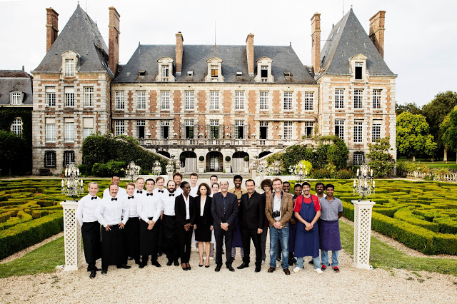](https://3.bp.blogspot.com/-_jKi-TT_RU4/XBq2XdDnFII/AAAAAAAAEfw/n-bv4D1ym8IpDJq3CD5Jrxd1-36b6AosgCLcBGAs/s1600/C%2527est%2BLa%2BVie%2521%2BStill%2B2.jpg)

Max is a veteran wedding planner who is thinking about selling on his business. For now, however, there’s something more pressing to worry about: organising a lavish wedding in a 17th century chateau. It’s no small task: there’s dozens of people to manage, unreliable electricity, a last-minute musician change, and an increasingly demanding groom. Soon, things start going very wrong indeed. Can Max and his team sort everything out without the guests noticing?  
  
The latest film from *Untouchable* directors Olivier Nakache and Éric Toledano is a gloriously manic French comedy. It hits the ground running and barely takes a breath as wedding disaster after disaster unfolds. With larger-than-life characters and laugh-out-loud set pieces, *C’est La Vie!*is a delight.

***Wednesday 20 March – The Wife***  
Dir: Björn Runge, 2017, UK, Sweden, 100 mins, Cert: 15a  
Starring: Glenn Close, Jonathan Pryce, Christian Slater, Max Irons, Harry Lloyd  
Language: English  
Trailer: <https://www.youtube.com/watch?v=d81IM0loH7o>

[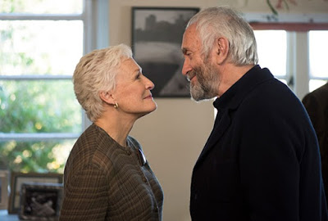](https://3.bp.blogspot.com/-M9g-em-rUE0/XB0OqYHT_WI/AAAAAAAAEgA/iH7DfQrns-Y2aFS74iSpYCsUUPFvL-cQACLcBGAs/s1600/the-wife.jpg)

There’s nothing more dangerous than a writer whose feelings have been hurt.” The speaker is Joan Castleman, the charming, enigmatically discreet and supportive wife of world-famous author and New York literary lion Joe Castleman. It is a fascinating and bravura performance from Glenn Close, in this hugely enjoyable dark comedy from director Björn Runge, adapted by Jane Anderson from the novel by Meg Wolitzer. Perhaps it’s Close’s career-best – unnervingly subtle, unreadably calm, simmering with self-control. Her Joan is a study in marital pain, deceit and the sexual politics of prestige. It’s a portrayal to put alongside Close’s appearances in Dangerous Liaisons and Fatal Attraction.  
  
The Castlemans are on the plane to Sweden, ready for Joe to get the Nobel prize. Yet they are being pestered on the flight by a certain Nathaniel Bone, part stalker-fan, part parasitic hack who wants Joe to cooperate with a warts-and-all biography he is planning to write. Joe gives him the contemptuous brush-off but Joan cautiously advises a more diplomatic treatment. It is a key moment in this hugely enjoyable drama when things begin to fall apart.